**How to start and stop mySQL server on Windows 10**

* Control Panel\System and Security\Administrative Tools
* Click on Services
* Click on “MySQL 5.7”, Start the service.
* When it says it’s “Running”, click on “MySQL Router”, Start the service.
* Start MySQL Workbench and click:

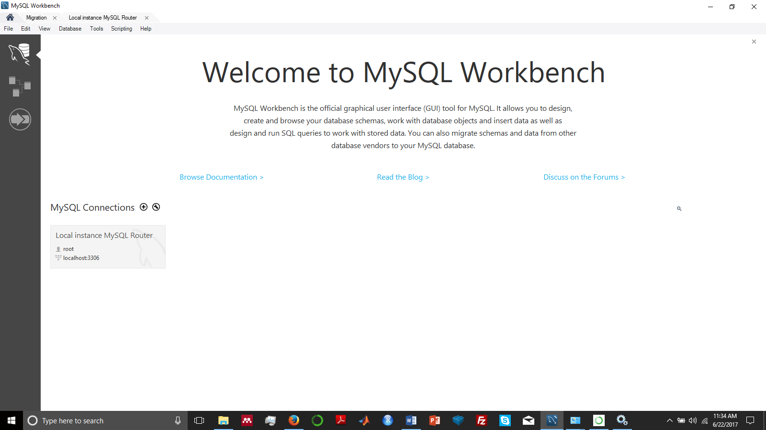

* Under Navigator, Management, Server Status it should say server is running.
* If there’s an error message somewhere, “could not connect to server”, something else is wrong.
* Under Navigator, Schemas, double-click on the desired database to work with.
* Now try to enter SQL statements like “SELECT * from invoices”, assuming the schema has that table.